**Refactoring Old Assignment : “ Carousel Slider ” assignment.**

Old code :

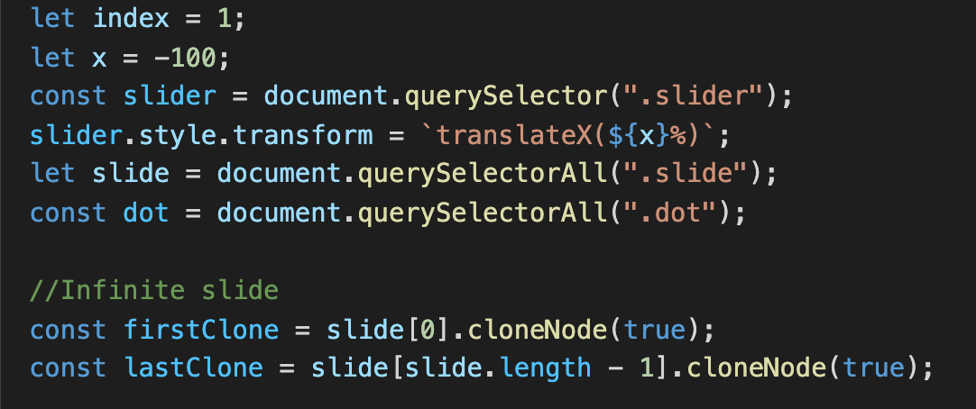

New code :

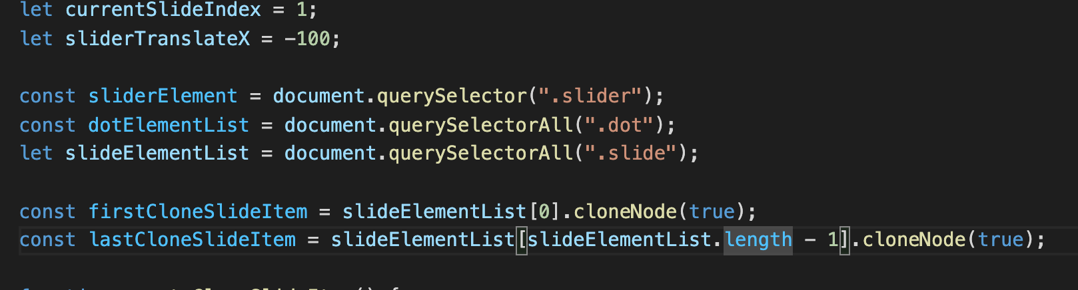

- The “index” declaration in the old code didn’t represent exactly the meaning of the index of the current slide so clearly so i changed it to “currentSlideIndex” so it can be more understandable

- Also with the “x” declaration it was also meaningless. I change it to “sliderTranslateX”.

It is more understandable. If someone want to see my code and they see the “sliderTranslateX” declaration, they would know the idea how I resolved this assignment.

- “dot” declaration is the list of element nodes so i change it to “dotElementList” so people can understand exactly what that code mean.

- Also width 2 clone slide item declaration below.

Old code :

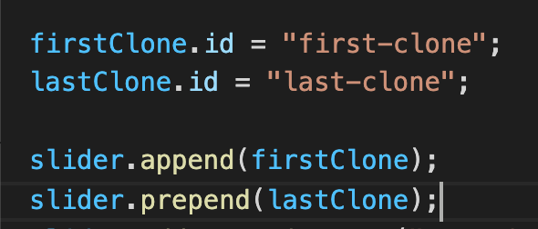

New code :

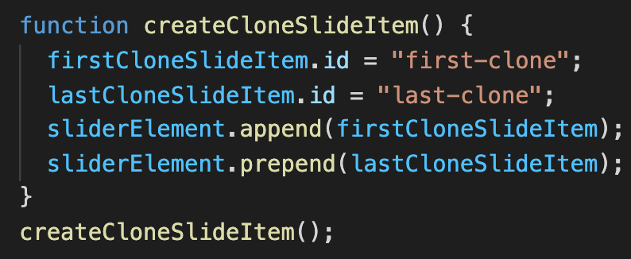

- I wrapped into a function so the code can be separated clearly and It would be easier to read.

Old code :

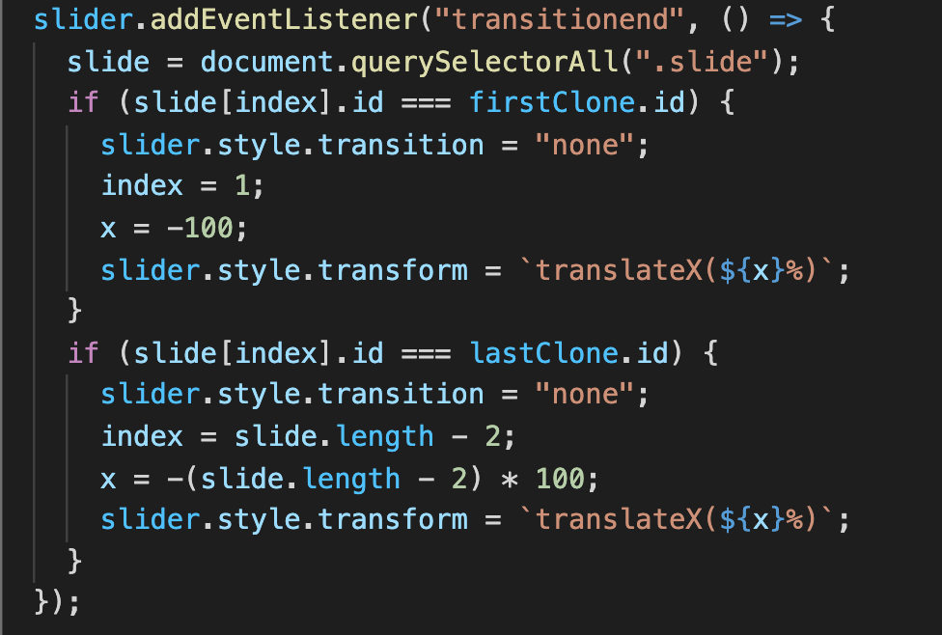

New code :

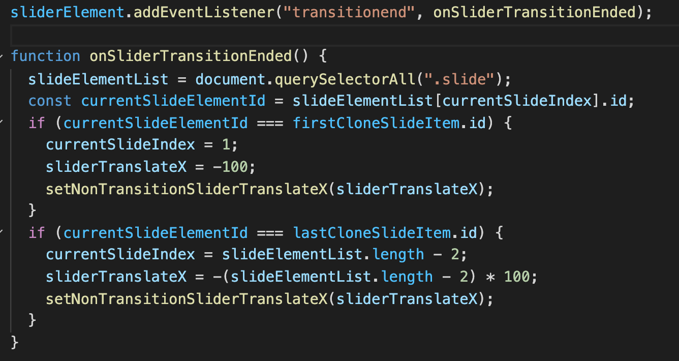

- In these code. I separated it to 2 part. First is a event listener action and the call back function. It easier to read and control the code.

- Sometimes, if we need to remove the event listener, so for the new code above it can be easier to remove.

- For the condition the “slideElementList[currentIndex].id” i used it multiple time so i just create a variable call “currentSlideElement” so i just call it to use and if i have to change anything about the “slideElementList[currentIndex].id” i just have to change it onetime instead of access to each line and change it.

- Then i see these lines :

sliderElement.style.transition = "none";

sliderElement.style.transform = `translateX(${x}%)`;

I use this 3 times, 2 times in the event callback and 1 time for setting the slider’s translateX for a default value. So i wrapped it into a function to easier reusing.

function setTransitionSliderTranslateX(x) {

sliderElement.style.transition = ".7s";

sliderElement.style.transform = `translateX(${x}%)`;

}

Old code :

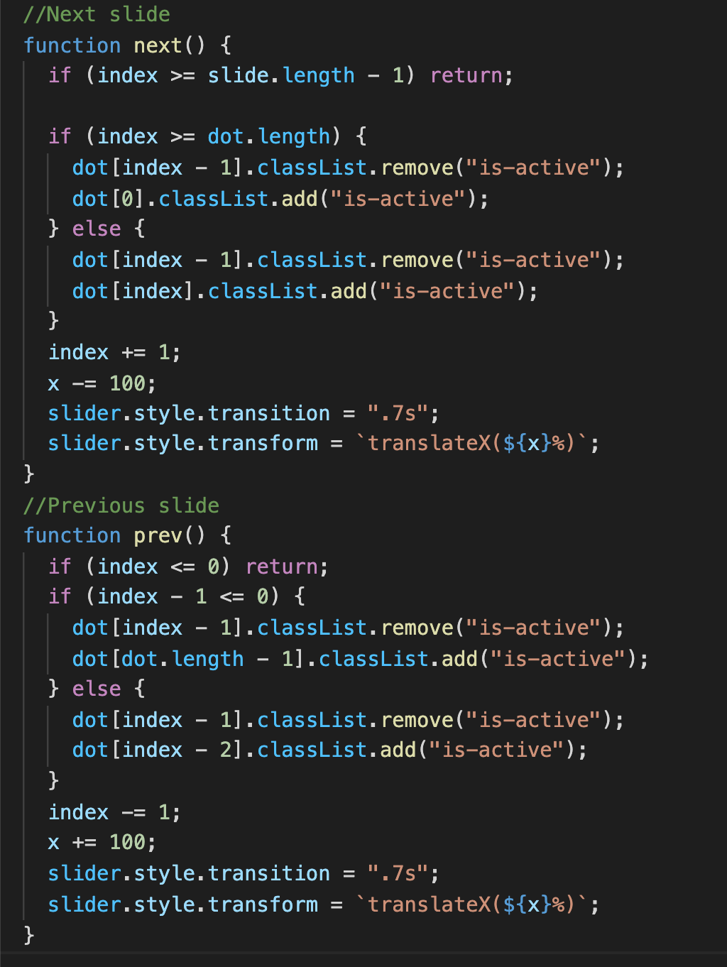

New code :

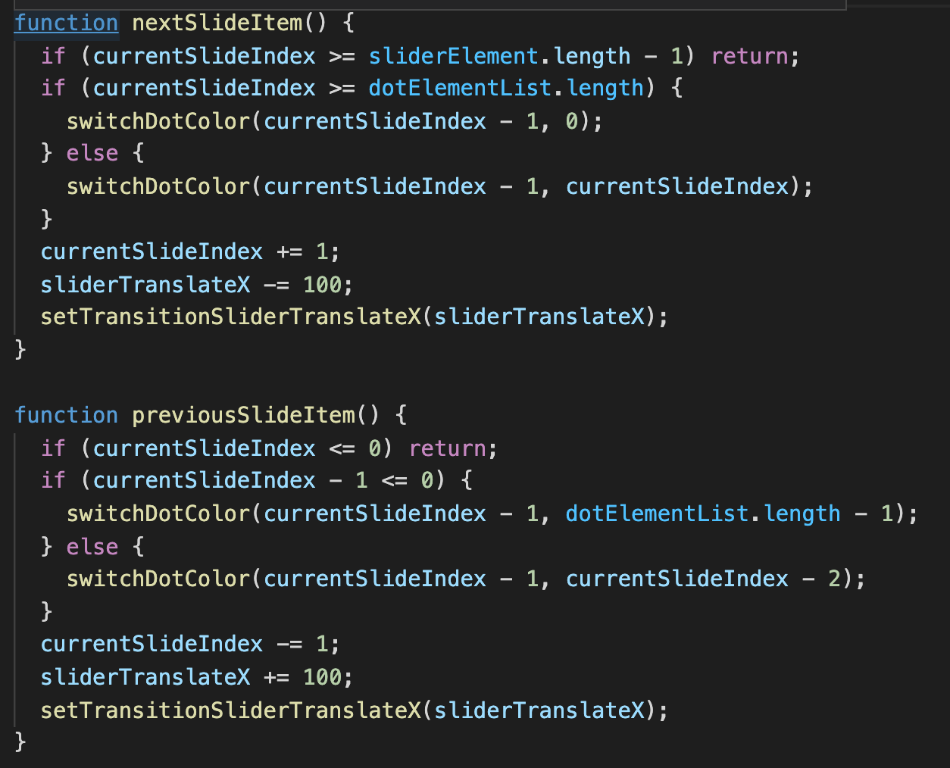

- In the old code the name of those 2 functions doen’t mean anything and doesn’t describe what inside the function is. So I change it to “nextSlideItem”.

- And inside the i reused these type of code multiple times:

dot[index - 1].classList.remove("is-active");

dot[index].classList.add("is-active");

So i wrapped it into a function so it can be more easier and named it “switchDotButtonColor()”.

function switchDotButtonColor(oldIndex, newIndex) {

dotElementList[oldIndex].classList.remove("is-active");

dotElementList[newIndex].classList.add("is-active");

}

- Also with these code here , i wrapped it into function name “setTransitionSliderTranslateX”:

slider.style.transition = ".7s";

slider.style.transform = `translateX(${x}%)`;

function setTransitionSliderTranslateX(x) {

sliderElement.style.transition = ".7s";

sliderElement.style.transform = `translateX(${x}%)`;

}

Old code :

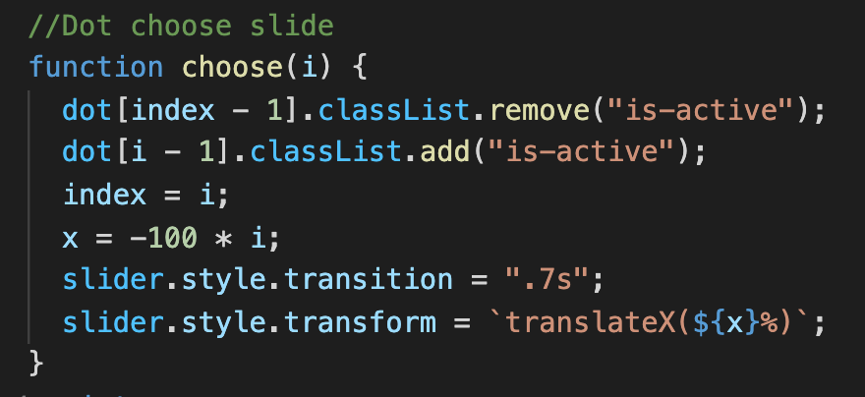

New code

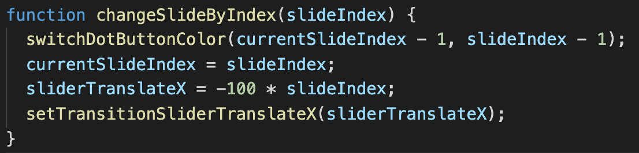

- The name of choose slide function doesn’t describe what the function do. I changed it to a more meaningful name “changeSlideByIndex”. It describe how the code inside runs and more understandable to read code.